Implement Snowflake Streams for Sales Data Processing

A retail company receives sales data in a staging table. The company wants to load this data into a final reporting table. After the initial load, only newly inserted or updated records should be processed using Snowflake Streams.

You need to create the database, tables, stream object, insert records, consume stream data, and update the final table using stream changes.

Task 1: Create Database
Create a transient database named:
STREAMS_DB
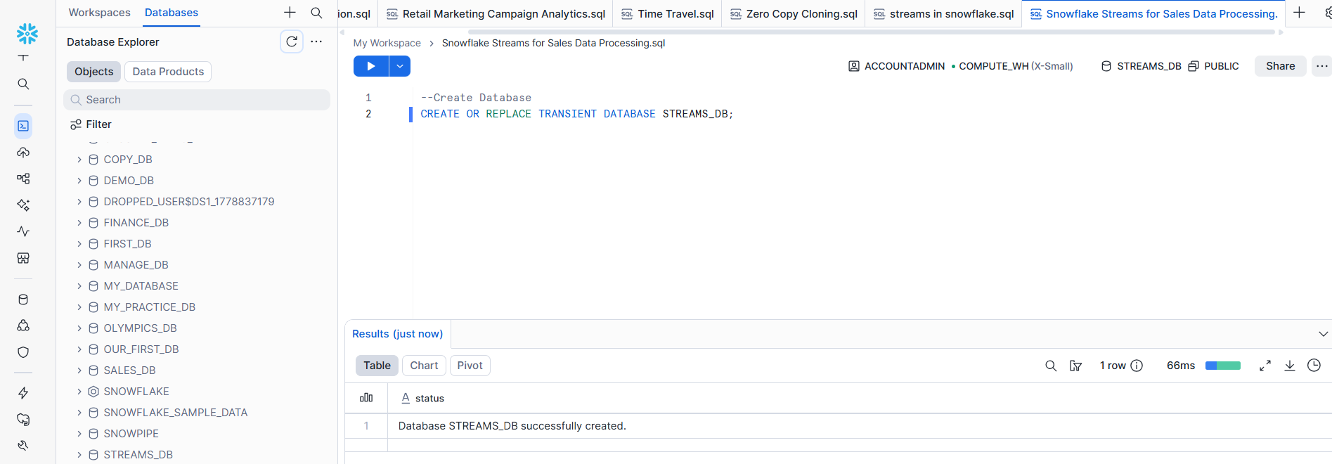
Task 2: Create Raw Sales Staging Table
Create a table named:
SALES_RAW_STAGING
The table should contain the following columns:
id
product
price
amount
store_id

Use suitable data types.
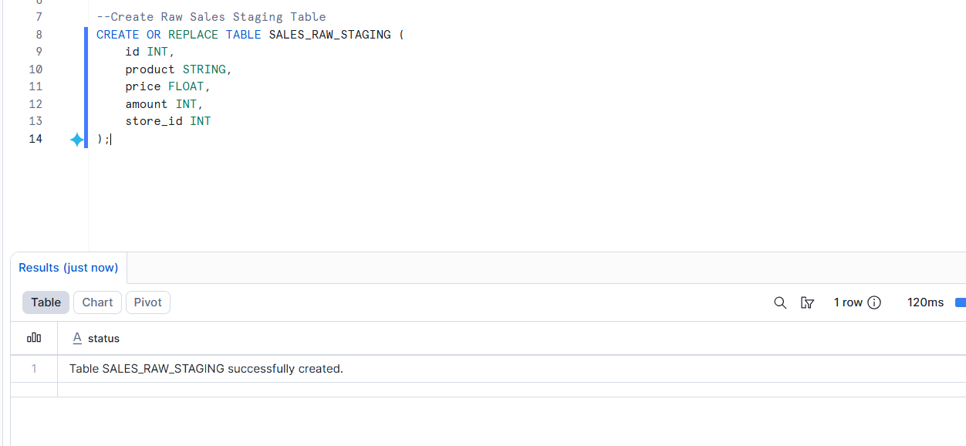

Task 3: Insert Initial Sales Data

Insert the following five records into SALES_RAW_STAGING:

id product price amount store_id
1 Banana 1.99 1 1
2 Lemon 0.99 1 1
3 Apple 1.79 1 2
4 Orange Juice 1.89 1
5 Cereals 5.98 2 1

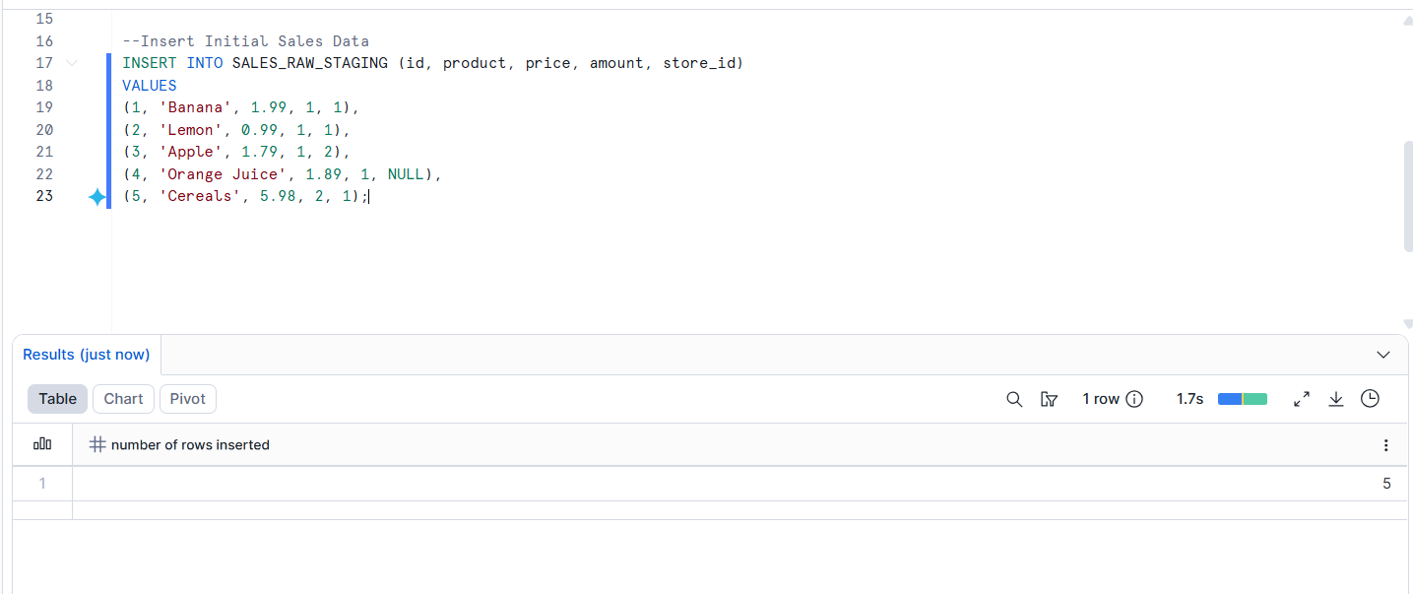

Task 4: Create Store Table
Create a table named:
STORE_TABLE
The table should contain:
store_id
location
employees
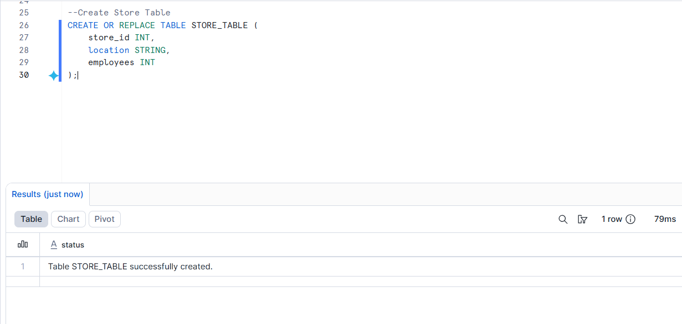

Task 5: Insert Store Data
Insert the following records into STORE_TABLE:

store_id location employees
1 Chicago 33
2 London 12
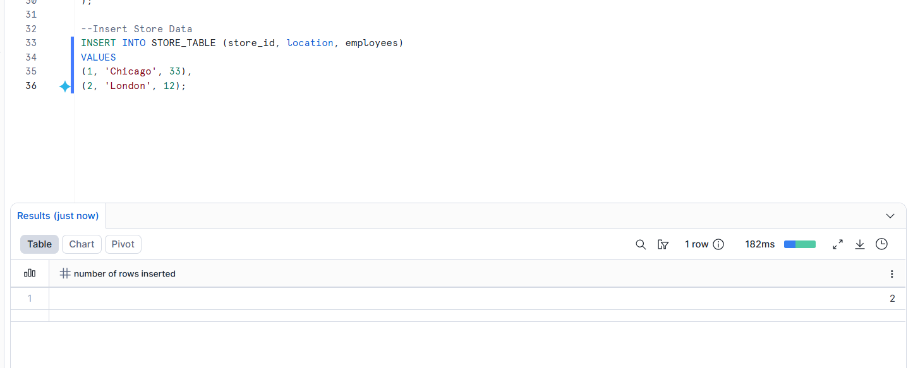
Task 6: Create Final Sales Table
Create a table named:
SALES_FINAL_TABLE
The table should contain:

id
product
price
amount
store_id
location
employees
This table will store sales data along with store location and employee details.
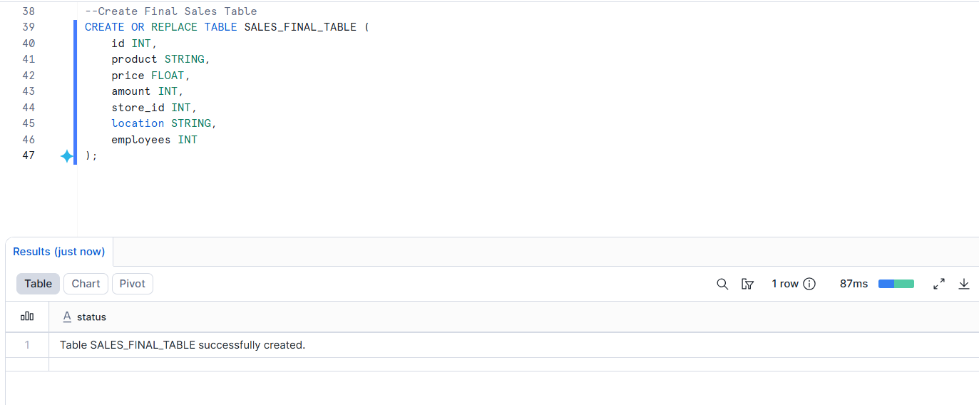
Task 7: Perform Initial Full Load
Load data from SALES_RAW_STAGING into SALES_FINAL_TABLE.
While loading, join:
SALES_RAW_STAGING
with:
STORE_TABLE
using STORE_ID.
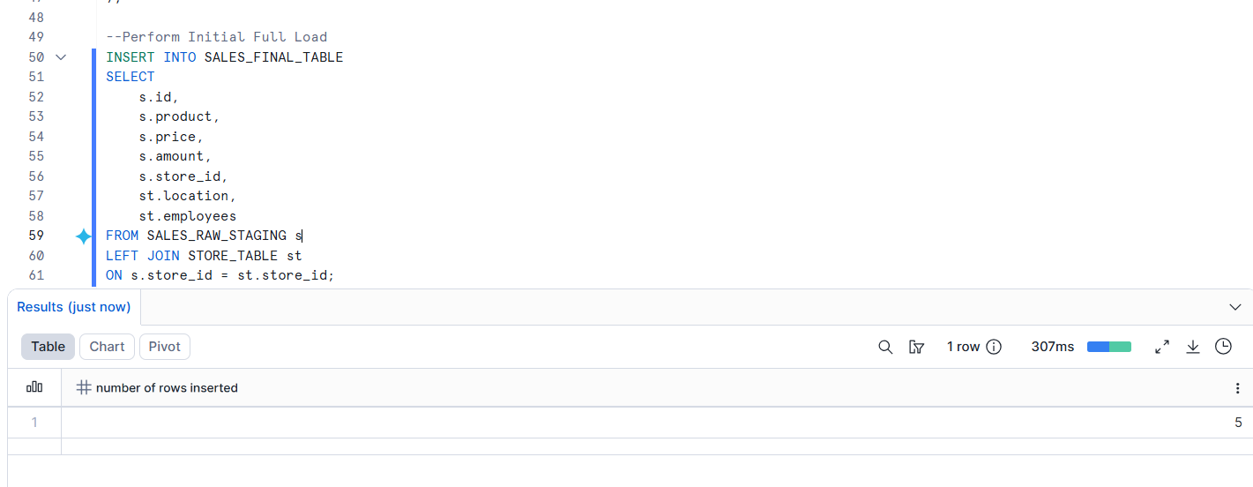

Task 8: Verify Initial Load
Display data from:

SALES_RAW_STAGING;
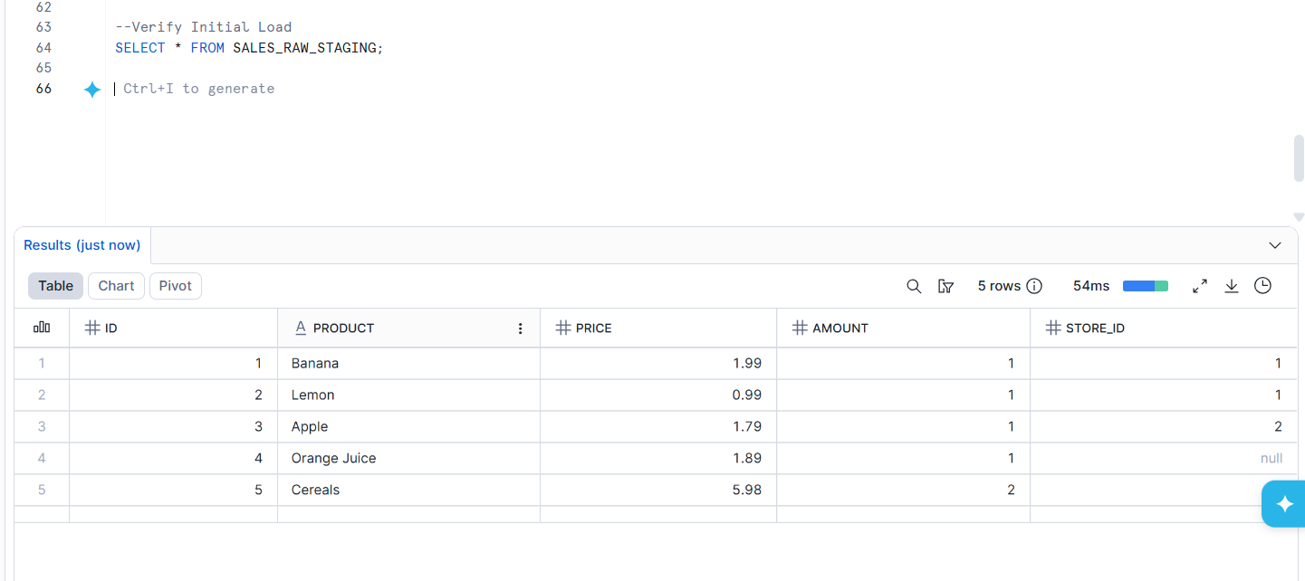
STORE_TABLE;
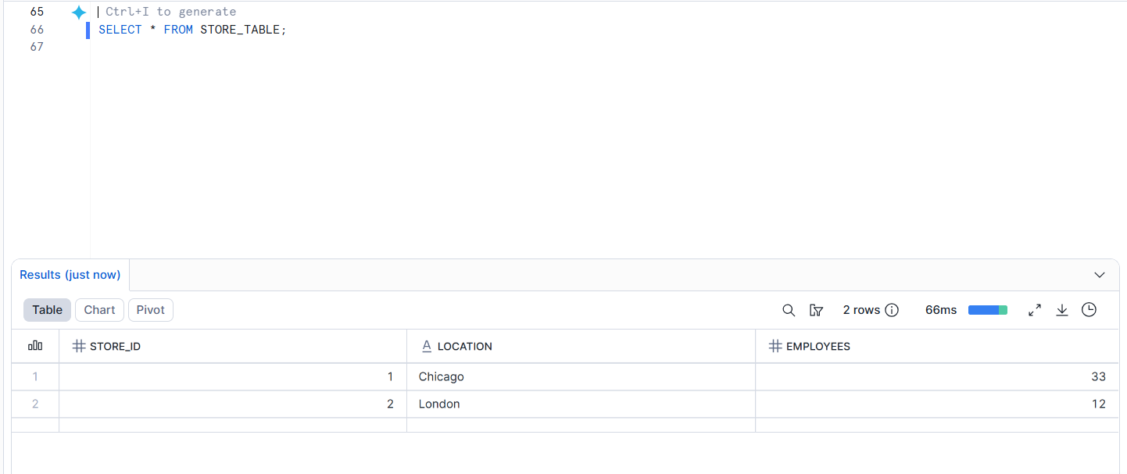
SALES_FINAL_TABLE;
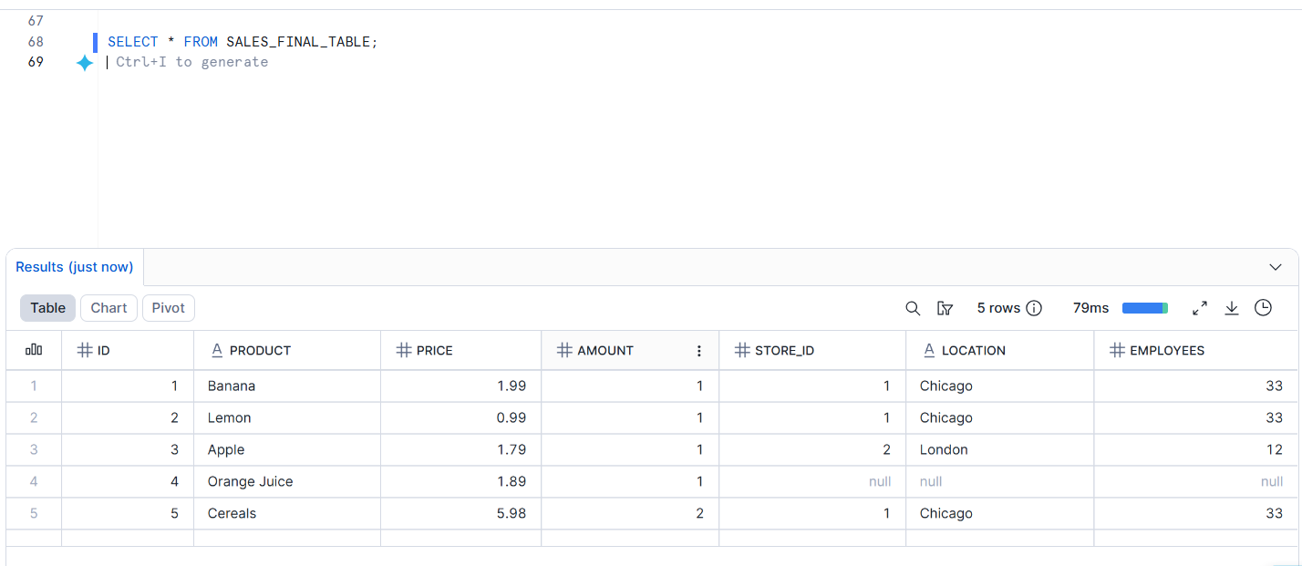
Confirm that SALES_FINAL_TABLE contains 5 records.

Stream Implementation
Task 9: Create Stream Object
Create a stream named:
SALES_STREAM
on top of:
SALES_RAW_STAGING

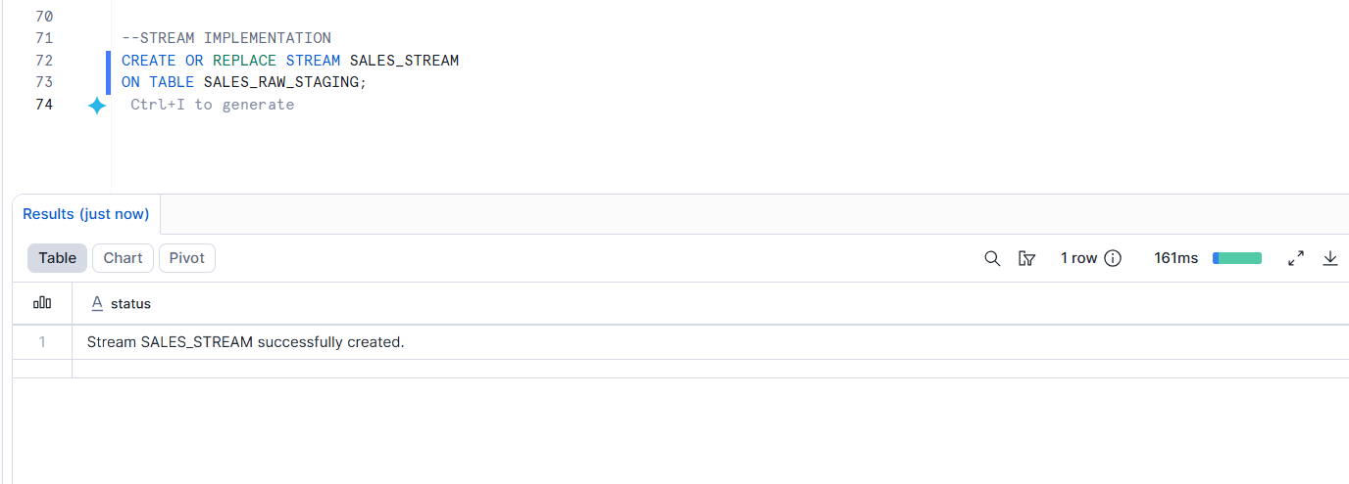

Task 10: View Stream Information
Execute commands to:
Show all streams.
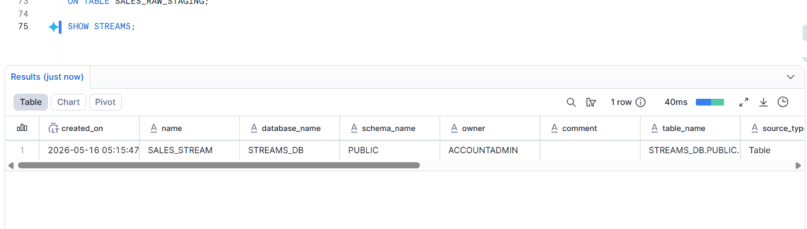
Describe the SALES_STREAM.
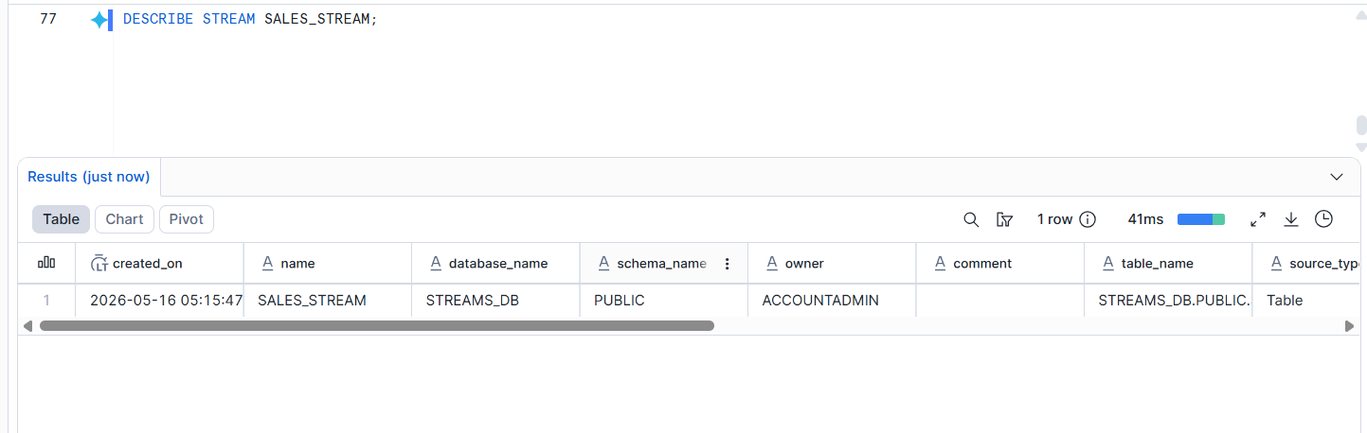
Select data from SALES_STREAM.
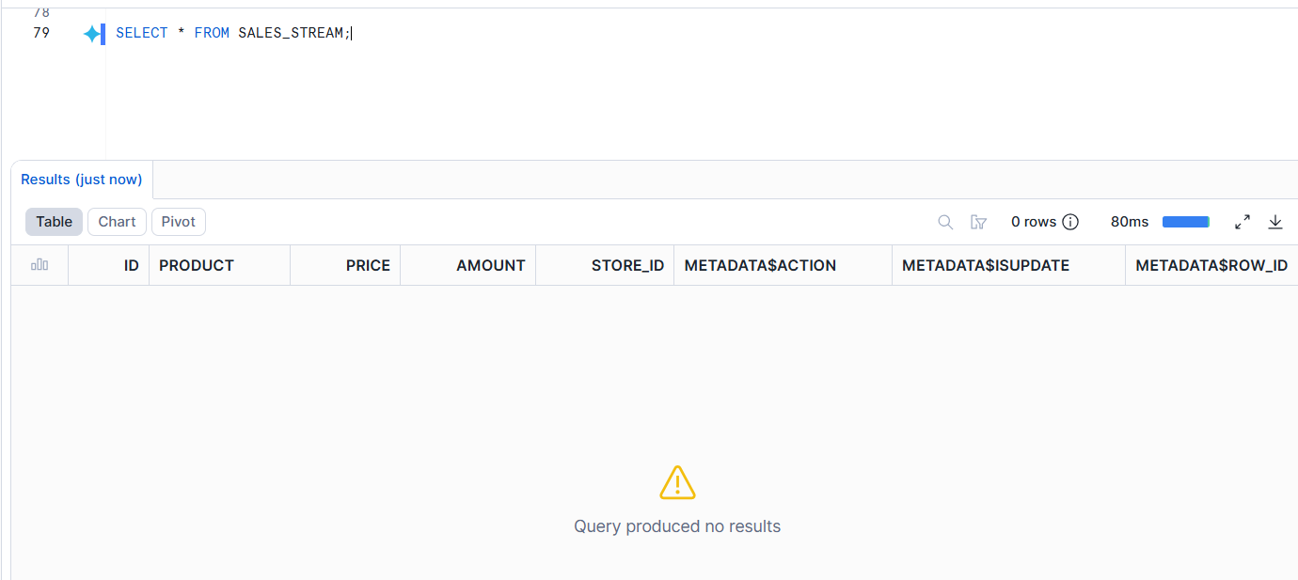
Answer this question:

Why is SALES_STREAM empty immediately after creation?
SALES_STREAM is empty immediately after creation because the stream starts tracking only the changes that happen after it is created. The existing records already present in the SALES_RAW_STAGING table are not considered as new changes, so no data appears in the stream initially.

Insert Change Capture
Task 11: Insert New Sales Records
Insert the following two records into SALES_RAW_STAGING:

id product price amount store_id
6 Mango 1.99 1 2
7 Garlic 0.99 1 1

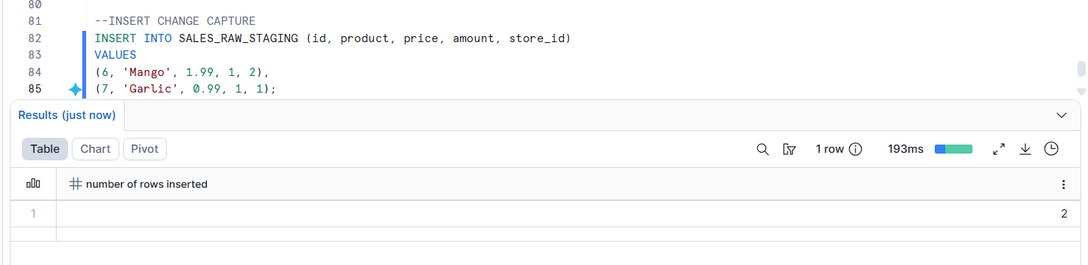

Task 12: Check Stream Data
Query SALES_STREAM.
Observe the new records and metadata columns:
METADATA$ACTION
METADATA$ISUPDATE
METADATA$ROW_ID
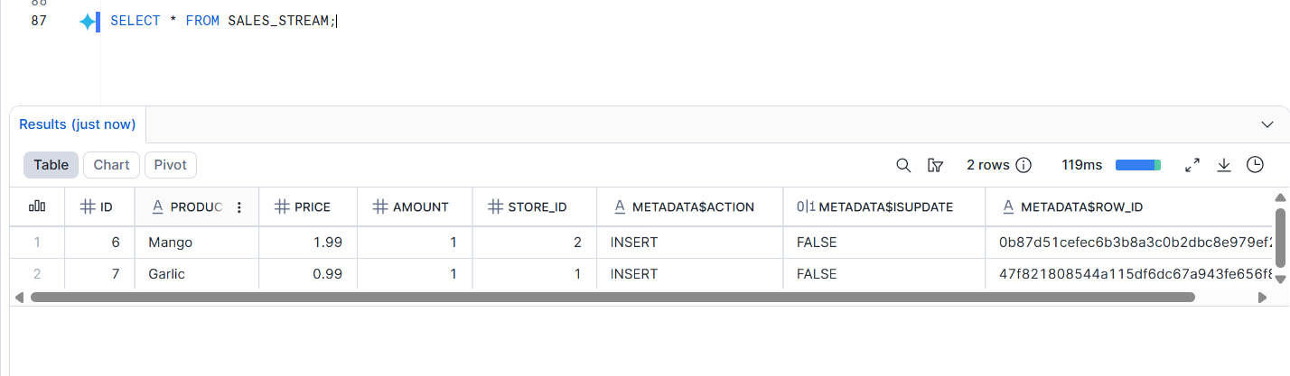
Answer this question:

What value do you see in METADATA$ACTION for newly inserted records?
For newly inserted records, the value shown in METADATA$ACTION is INSERT. This indicates that the records were newly added to the source table.
Task 13: Verify Source and Target Tables

Check data in:

SALES_RAW_STAGING;
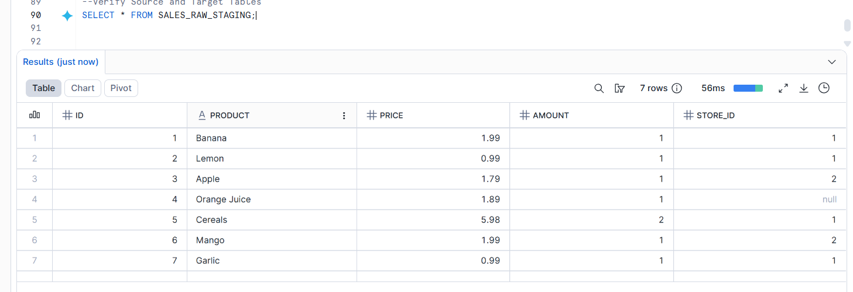
SALES_FINAL_TABLE;
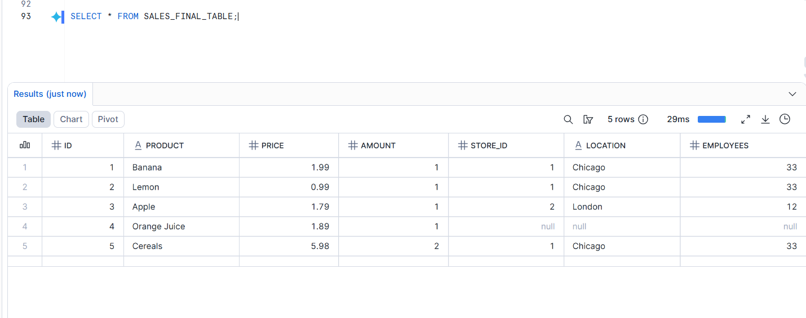
Answer this question:

Are the new records available in SALES_FINAL_TABLE before consuming the stream?
No, the new records are not available in SALES_FINAL_TABLE before consuming the stream. The stream only captures the changes made in the source table, but those changes will be loaded into the final table only after executing the INSERT or MERGE operation using the stream data.
Task 14: Consume Stream Data

Insert new records from SALES_STREAM into SALES_FINAL_TABLE.

While inserting, join the stream with STORE_TABLE using STORE_ID.
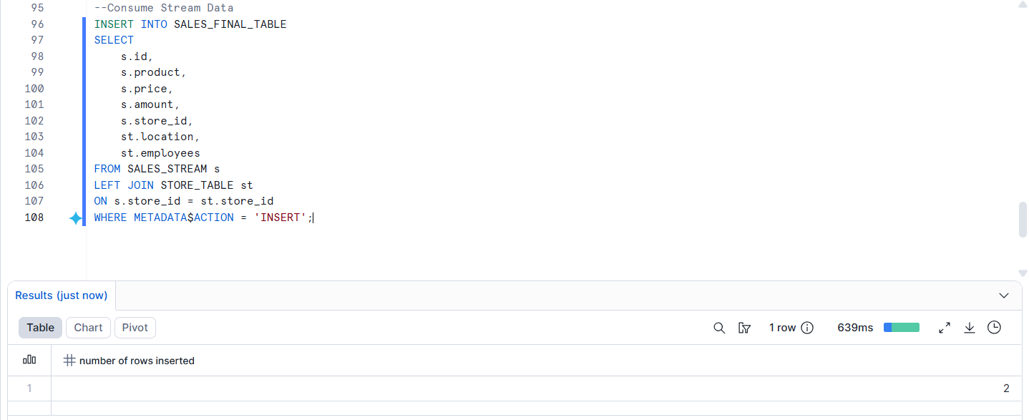

Task 15: Verify Stream After Consumption
Query:
SELECT * FROM SALES_STREAM;
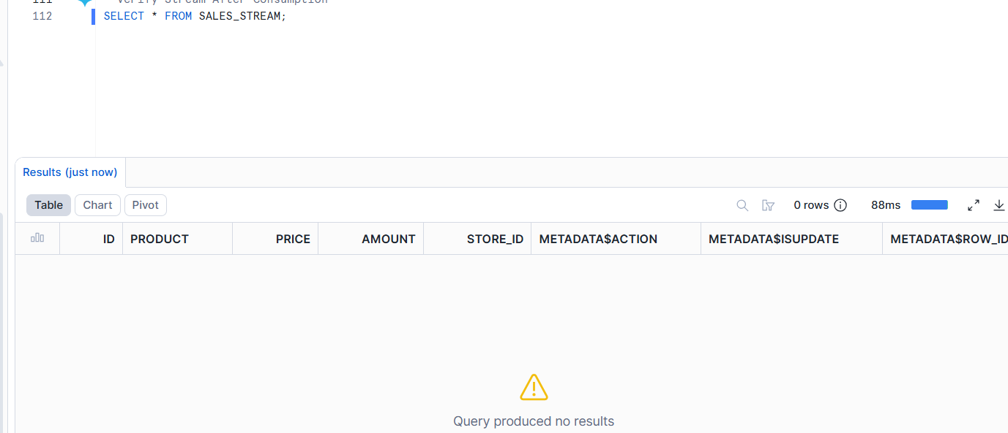
Answer this question:

Why did the stream become empty after inserting data into SALES_FINAL_TABLE?
The stream became empty after inserting data into SALES_FINAL_TABLE because the changes captured by the stream were already consumed. Snowflake streams work like change trackers, and once the tracked records are used in an INSERT or MERGE operation, those changes are marked as processed and no longer appear in the stream.
Second Insert Change Capture
Task 16: Insert More Sales Records
Insert the following two records into SALES_RAW_STAGING:

id product price amount store_id
8 Paprika 4.99 1 2
9 Tomato 3.99 1 2
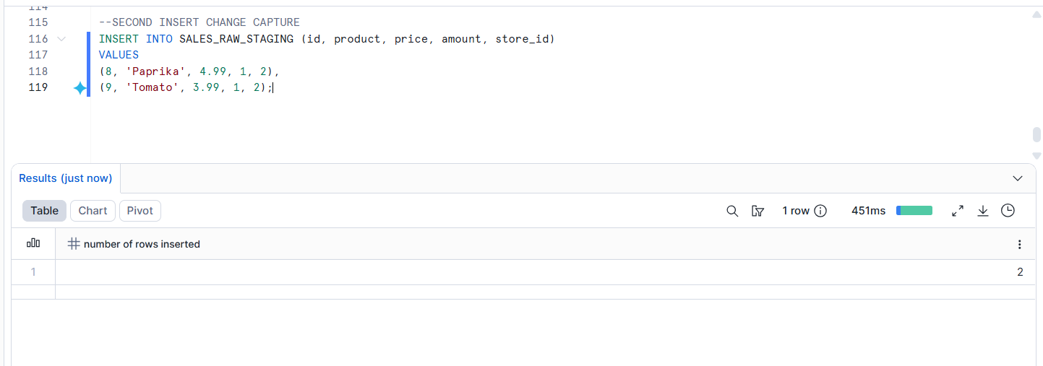
Task 17: Consume Second Stream Data

Consume the newly captured stream records and insert them into SALES_FINAL_TABLE.
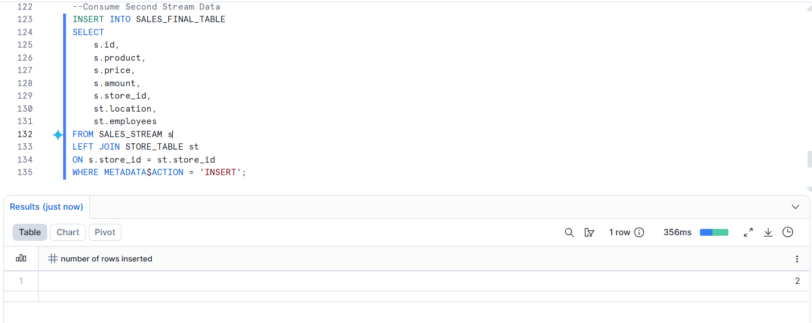
Task 18: Verify Final Insert Output
Display data from:
SALES_FINAL_TABLE;
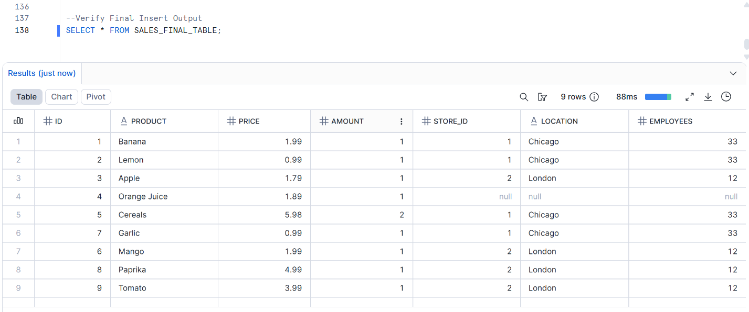
SALES_RAW_STAGING;
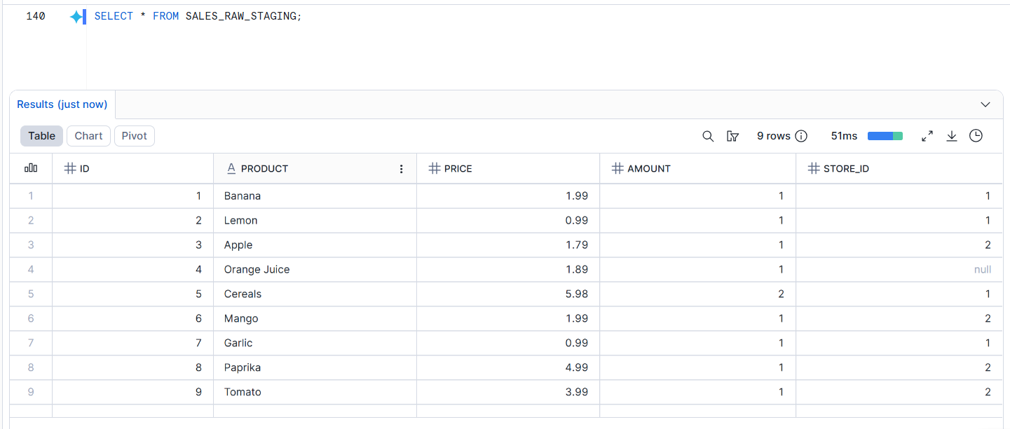
SALES_STREAM;
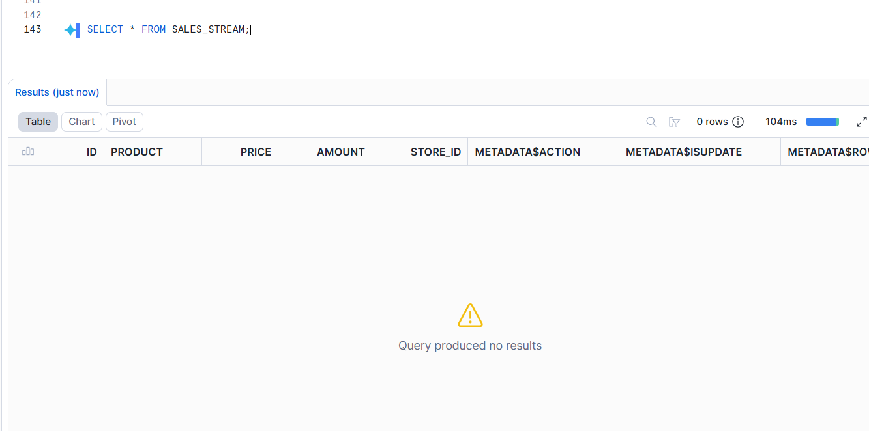
Answer:

How many records are now available in SALES_FINAL_TABLE?
There are now 9 records available in SALES_FINAL_TABLE. Initially, 5 records were loaded, then 2 new records were inserted in the first stream capture, and another 2 records were added in the second stream capture.

Update Change Capture
Task 19: Check Existing Data Before Update

Display records from:

SALES_RAW_STAGING;
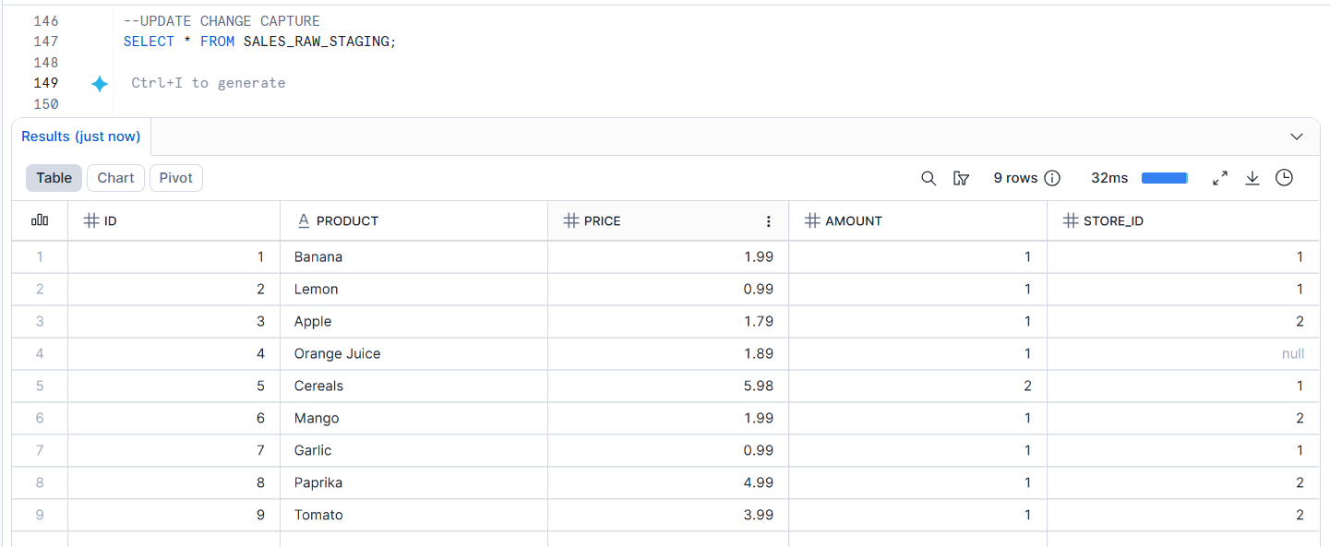
SALES_STREAM;
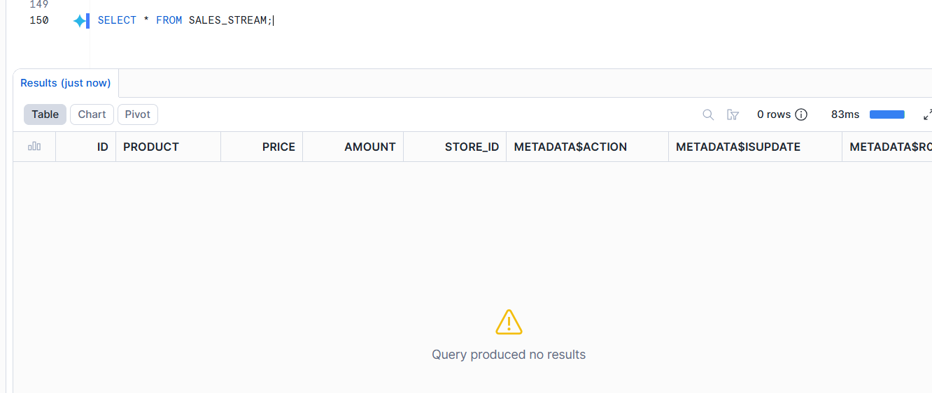
Task 20: Perform First Update

Update the product name:
Banana
to:
Potato
in SALES_RAW_STAGING.
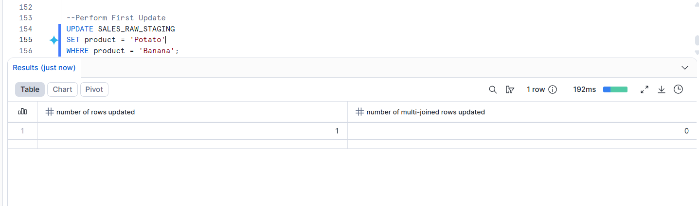
Task 21: Check Stream After Update
Query:
SELECT * FROM SALES_STREAM;
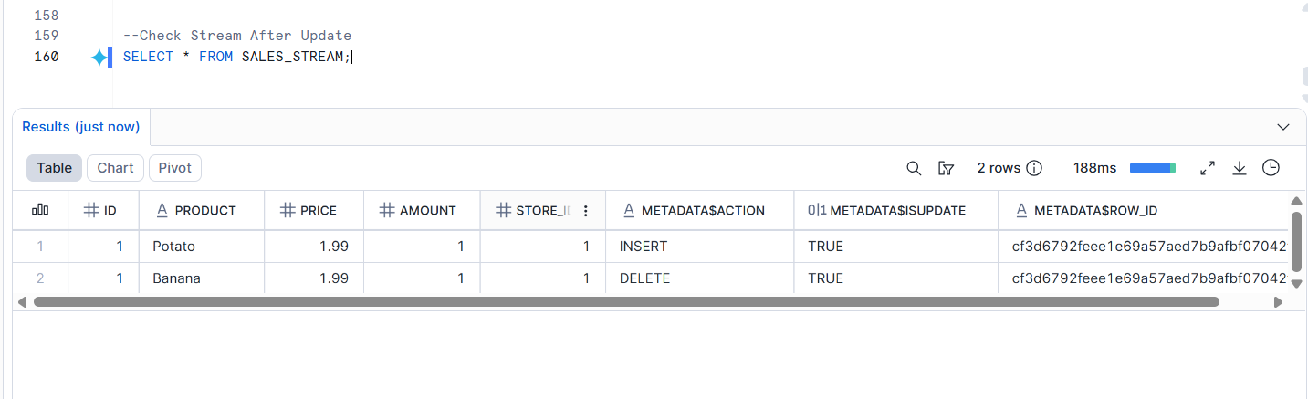
Answer:

How does Snowflake represent an UPDATE operation inside a stream?
Snowflake represents an UPDATE operation inside a stream as two separate actions: a DELETE for the old record and an INSERT for the updated record. This helps Snowflake track both the previous and the new values of the changed data.
Task 22: Consume Update Using MERGE
Use a MERGE statement to update the corresponding record in SALES_FINAL_TABLE.
Condition:
Match records using ID
Update only records where METADATA$ACTION = 'INSERT'
and METADATA$ISUPDATE = TRUE

Update the following columns:

product
price
amount
store_id
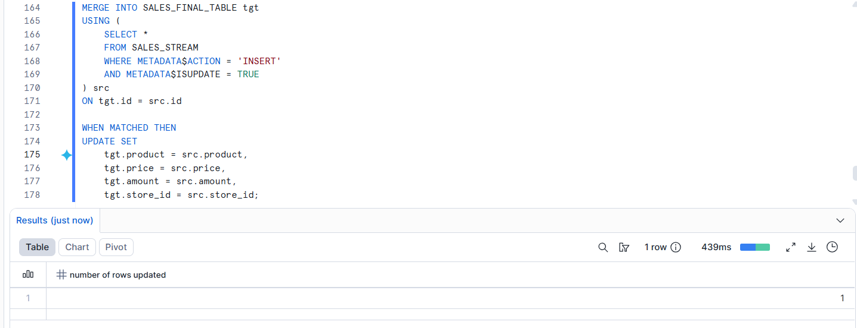
Task 23: Verify First Update

Display data from:

SALES_FINAL_TABLE;
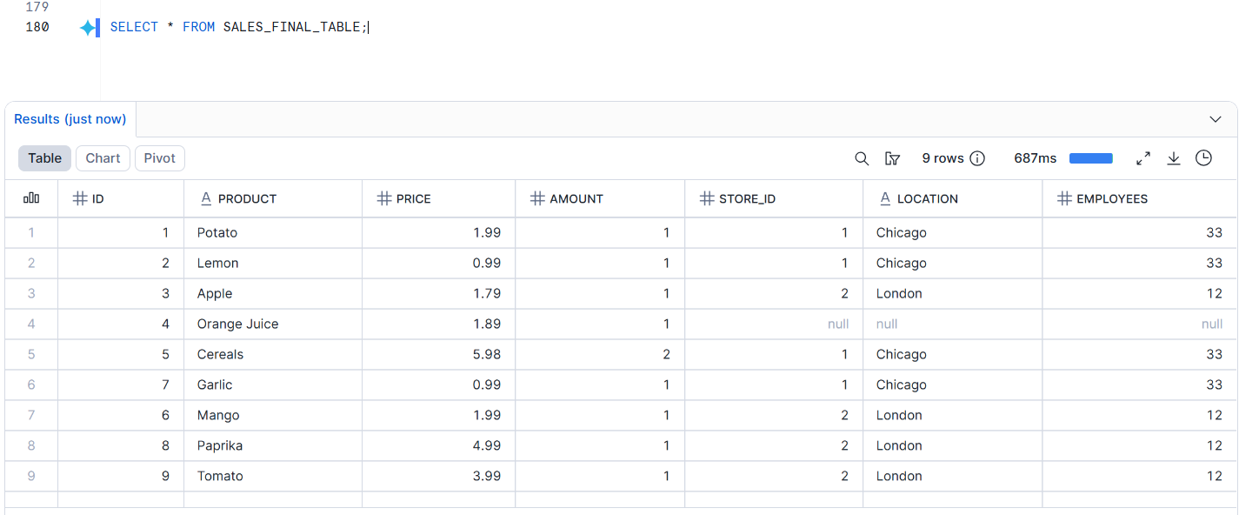
SALES_RAW_STAGING;
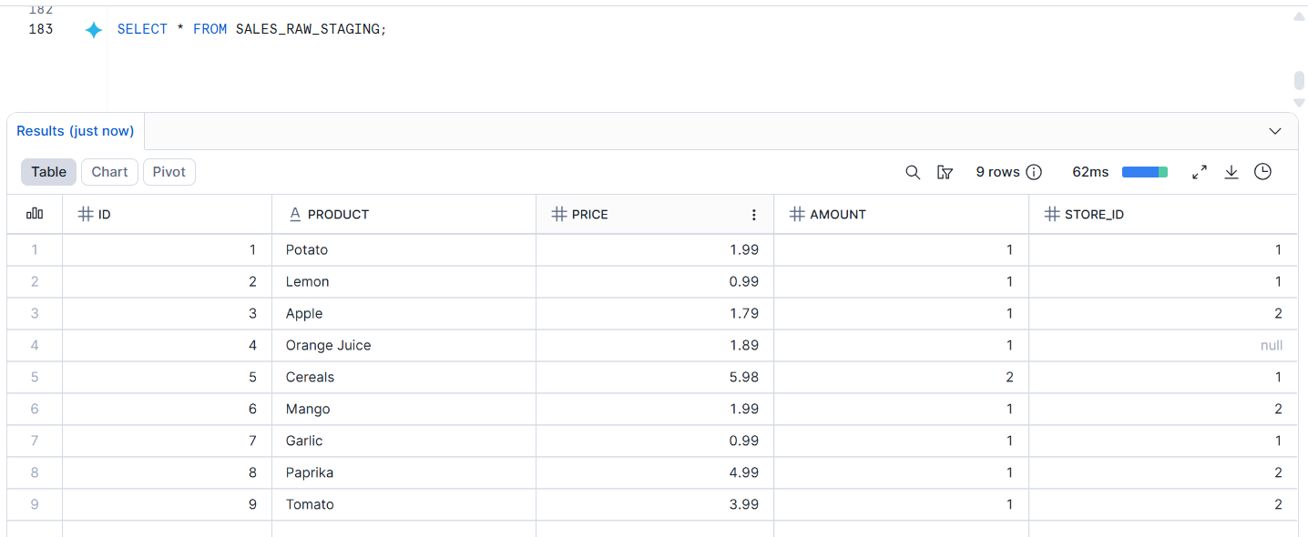
SALES_STREAM;
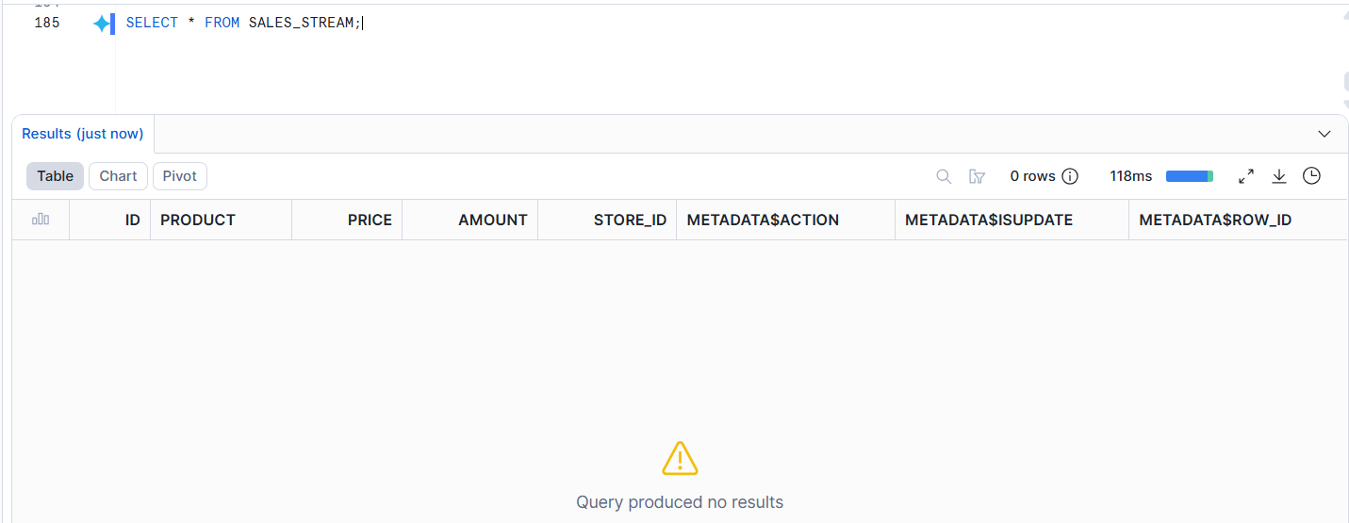
Answer:

Is Banana changed to Potato in SALES_FINAL_TABLE?
Yes, Banana was successfully updated to Potato in SALES_FINAL_TABLE after consuming the stream data using the MERGE statement.
Second Update Change Capture
Task 24: Perform Second Update
Update the product name:

Apple

to:

Green apple

in SALES_RAW_STAGING.
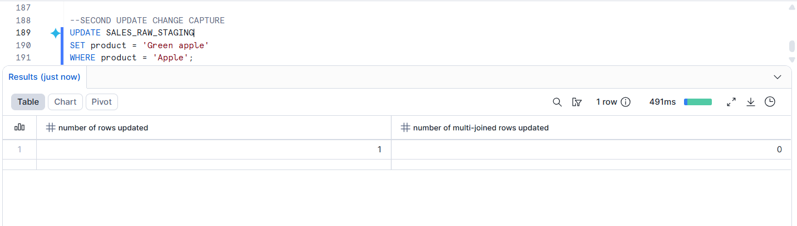
Task 25: Consume Second Update Using MERGE

Use a MERGE statement to update the changed record in SALES_FINAL_TABLE.
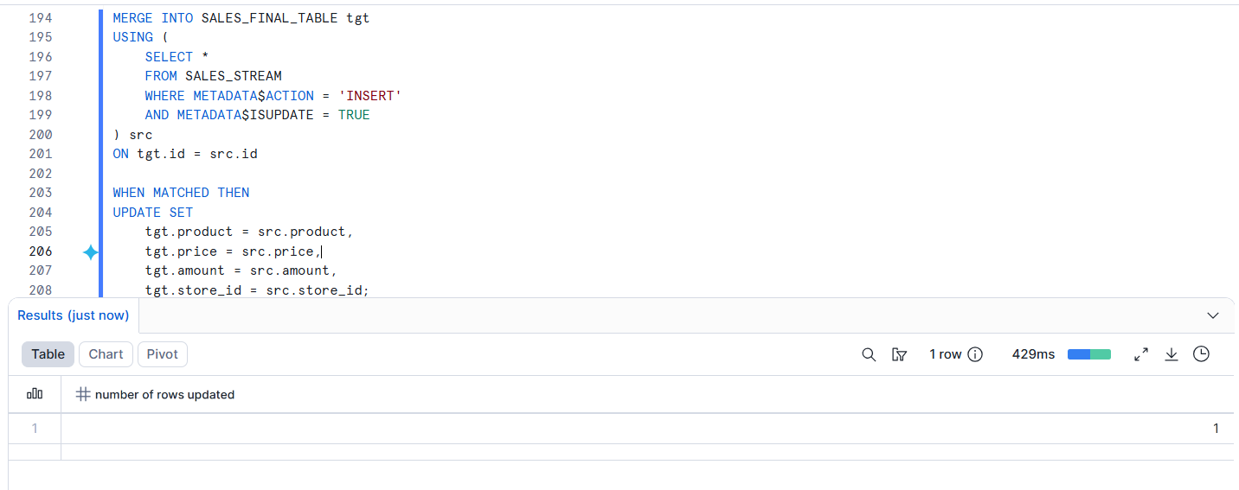
Task 26: Verify Final Output

Display data from:

SALES_FINAL_TABLE;
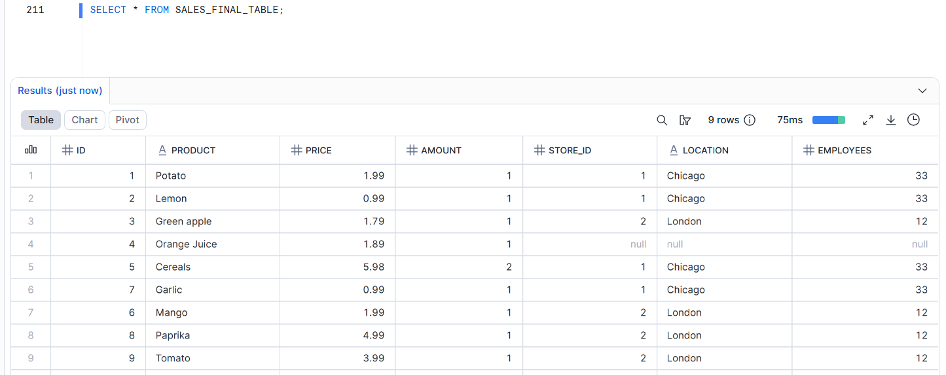
SALES_RAW_STAGING;
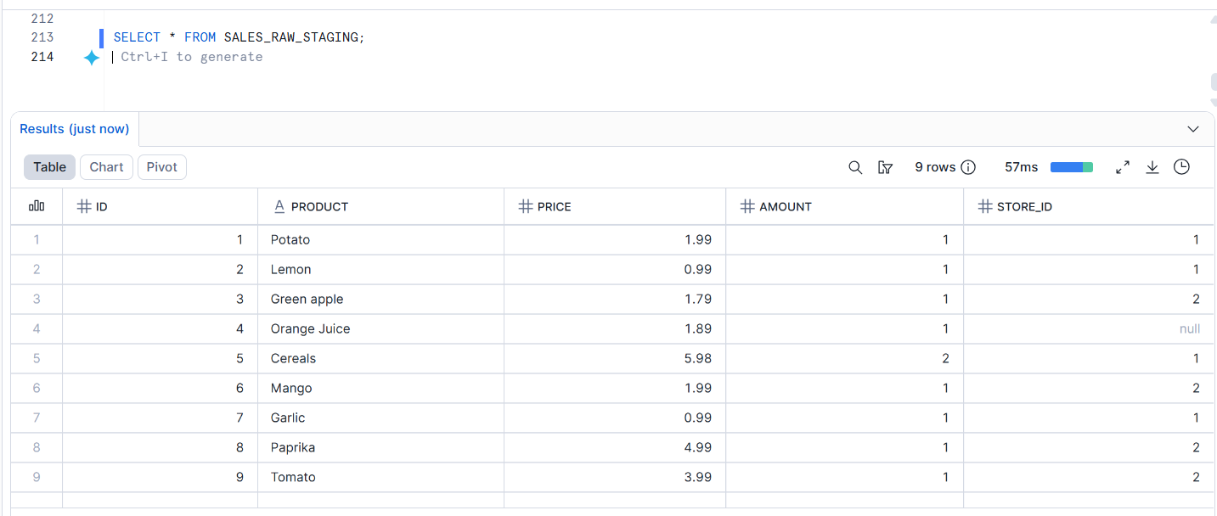
SALES_STREAM;
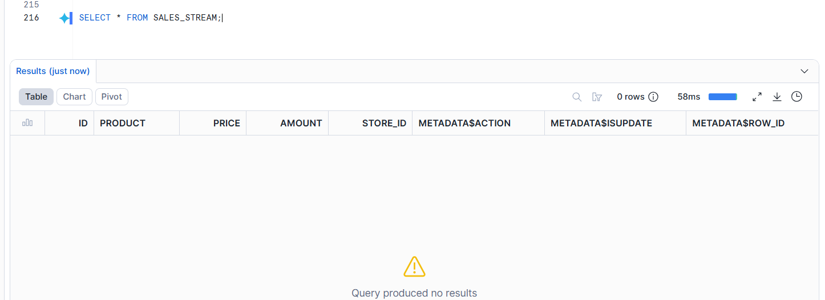
Answer:

Is Apple changed to Green apple in SALES_FINAL_TABLE?
Yes

